Items to be Verified Before Publication in the Hiroshima University Institutional Repository

Student Number （ D123456 ） Name（ TARO HIRODAI ）

Regarding the “Unavoidable Circumstances” section under point 3 (Items to verify concerning publication in the Hiroshima University Institutional Repository) of the Doctoral Dissertation Submission and Publication Confirmation Application Form (hereinafter referred to as the “Confirmation Form”), please check the points below which apply to your dissertation, and complete the Confirmation Form accordingly.
Choose (1) Publisher’s PDF or (2) Author final version or (3) Preprint

1. Please confirm what version your Ph. D dissertation is from the following list and write the appropriate number in the right box.
(1)

(1) Publisher’s PDF
A PDF file that is published and available on the website of a journal. It includes a manuscript with only minor differences from the publisher’s PDF file. It is often called the Publisher’s version or the Version of Record (VoR).
(2) Author final version
A peer reviewed manuscript of a journal article. It is not a published version and does not have the logo of the publisher, official pagination or DOI. It is also called an accepted version, post-print or peer-reviewed version.
(3) Preprint
A manuscript that has not yet been submitted or peer reviewed. It might be called a submitted version.

2. Complete the Confirmation Form based on the items under the version you selected in number 1.
Version | Items to be verified
(1)  Publisher’s PDF | If your Ph. D. dissertation is/includes Publisher’s PDF, and  ☐ Open Access journal article (“open access” is clearly indicated in the article)  ☐ Journal article published by Elsevier  ☐ Journal article published in Hiroshima Journal of Medical Sciences  then please check the appropriate box above. You have the right to deposit your dissertation (Publisher PDF) into the HU repository. If there are no other applicable options from A to H, please check “The applicant has no unavoidable circumstance as described in the Degree Regulation of the Hiroshima University, Article 14.2.（as described below A – H）”on the Confirmation Form.  If not, you don’t have the right to deposit your dissertation (Publisher PDF) to the HU repository. So please check Option D “Copyrights have been granted, and permission from the copyright holder (publishing company or academic society) has not yet been obtained” on the Confirmation Form.
(2)  Author Final Version | If your Ph. D. dissertation is the author final version (peer reviewed and accepted manuscript, not Publisher’s PDF), whether you can deposit your dissertation into the HU repository depends on the journal or the publisher that your article is published in.  You should check your right for deposit on the Sherpa Romeo website below:  https://www.sherpa.ac.uk/romeo/  When the website shows that the journal or the publisher allows the author to deposit an author final version (accept version) into a repository, you have the right to deposit your dissertation (author final version) into the HU repository. So please check “The applicant has no unavoidable circumstance as described in the Degree Regulation of the Hiroshima University, Article 14.2.（as described below A – H）” on the Confirmation Form.  If the journal or the publisher does not allow the author to deposit an author final version (an accept version) into a repository, you don’t have the right to deposit your dissertation (author final version) into the HU repository. So please check Option D “Copyrights have been granted, and permission from the copyright holder (publishing company or academic society) has not yet been obtained” on the Confirmation Form.  Please see the next page for more details about how to check your right to deposit on the Sherpa Romeo website.
(3)  Preprint | If your Ph. D dissertation is a preprint (not submitted yet), you should not to deposit your dissertation into the HU repository because it may cause some problems when you submit an article based on your dissertation to a journal. So please check Option G “The dissertation is planned to be submitted/published and publication of the whole text would create obvious disadvantages to the applicant.”
Note: The file (version) which you will deposit the HU repository must be the same as the one submitted as your dissertation. For example, if you submit the accepted manuscript (author final version) of the open access article as your Ph. D. dissertation, you should deposit the accepted manuscript (author final version), not Publisher’s PDF file into the HU repository.

【How to check your right to deposit your dissertation into the HU repository on the Sherpa Romeo website】

First, access the Sherpa Romeo website: https://v2.sherpa.ac.uk/romeo/search.html, then search the journal or publisher in which your dissertation (article) has been published or accepted.
Here are two examples of the search result:

You are not permitted to deposit the author final version
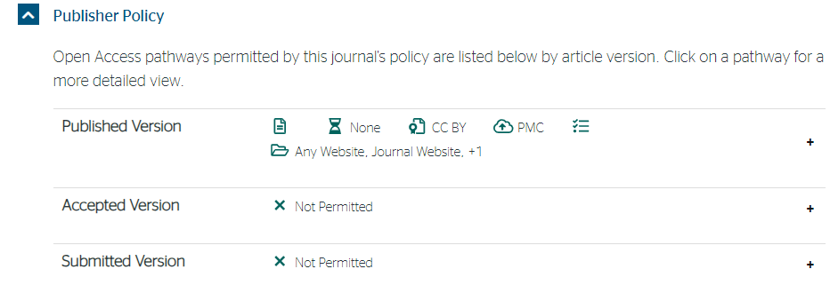

Please note that some journals, Scientific Reports, BMC Nursing and Liver Cancer etc., do not permit you to deposit your final manuscript (author final version) of your article even if it is open access. (as of December 2023)

You are permitted to deposit the author’s final version
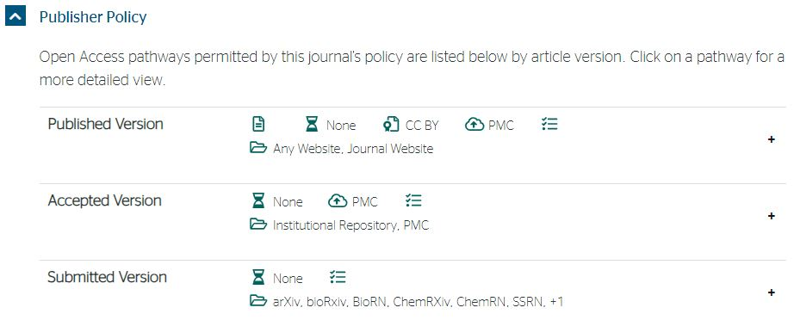

Some publishers such as Plos, Frontiers and MDPI permit you to deposit your final manuscript (author final version) of the open access article. (as of December 2023)

Reference: Version of the Article

It is possible to deposit articles in the Hiroshima University Repository that meet the following conditions.

- Publisher’s Version
・Open access articles, articles published in Elsevier journals, articles published in Hiroshima Journal of Medical Sciences・広島大学医学雑誌.

- Author’s Final Version
Only articles that have been allowed to be publicized in the repository by the publisher can be publicized in the repository.

In many cases, it is not the publisher's version itself that is allowed to be registered in the institutional repository, but the author’s final manuscript (the version that reflects the peer review but has not had the final layout adjusted by the publisher, etc.) just before it is accepted by the publisher. It is not permitted to add value (copyediting, formatting, technical improvements, and in some cases page layout) to the author's final manuscript equivalent to that of the publisher's version.

A paper can be viewed as several "versions" at each stage from initial submission to publication, depending on the status of peer review and publisher typesetting.
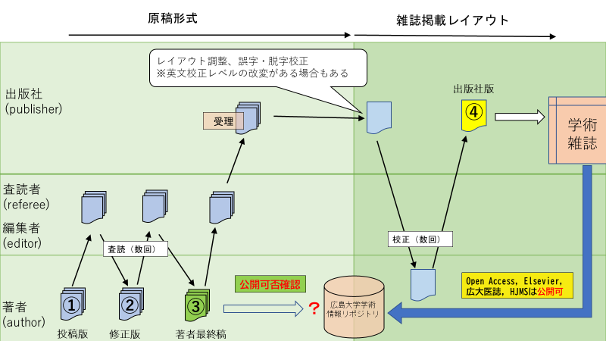
① Submitted Version (Manuscript that has been submitted to a publisher before being peer reviewed)
submitted version, pre-print
② Revised Version (Manuscript that has been revised after peer-review)
revised version
③ Author’s Final Manuscript Version (Manuscript just before it is accepted by the publisher after peer review)
final author's manuscript, accepted author manuscript, peer-reviewed version, post-print
④ Publisher’s Version (Manuscripts that were accepted, typeset by a publisher and published in a journal)
publisher's version, final publisher's version, VoR (Version of Record)

