Application for Academic Guidance and Approval Form

　　Date:

Hiroshima University

Executive Vice President (Community Collaboration, Funding and Alumni Associations)

Applicant

Name:

Address:

Representative:

Applicant accepts the “Rules for Conditions of Academic Guidance” on the back and apply for academic guidance as follows.

|  |  |  |
| --- | --- | --- |
| Topic of Academic Guidance | |  |
| Purpose and Outline | | Purpose： |
| Outline： |
| Term of Academic Guidance  （Number of Hours） | | Start Date： 　　 　　Finish Date：  Total hours： 　hours |
| Fee (JPY) | | Japanese Yen  　　 (Including consumption tax and local consumption tax/Prepayment) |
| Supervisor at Hiroshima University | | Affiliation：  Title：  Name： |
| Coordinator Name | |  |
| Contact Information for Applicant | Company Name |  |
| Department Name |  |
| Tel |  |
| E-Mail |  |
| Address |  |
| Notes (Special Conditions, etc.) | |  |

Contact for Notices and Billing

※ If the delivery address is the same as the requester's contact information above, there is no need to enter it.

|  |  |
| --- | --- |
| Department Name |  |
| Tel |  |
| E-Mail |  |
| Address |  |

※ Payment of the Fee of Academic Guidance shall be made by the end of the following month the invoice is issued.

Important Notice

・Please note that the " Rules for Conditions of Academic Guidance " cannot be changed.

・If there are any special conditions other than those stated in the " Rules for Conditions of Academic Guidance " please write them in the "Notes" section.

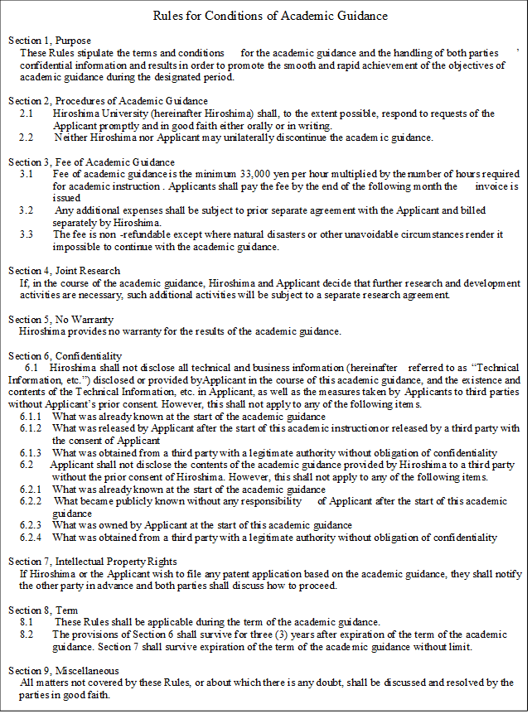

（ To be filled out by the University）

|  |  |
| --- | --- |
| Approval  by Authorized Signer | Supervisor |
|  | Supervisor (Affiliation)  Name:  University Phone Number:  E-mail: |
| Accounting unit |  |
| If your application will be accepted in a department other than your own, please enter that department. |  |

Hiroshima University approves the above application for academic guidance.

Date:

TO:

Hiroshima University

Executive Vice President

(Community Collaboration, Funding and Alumni Associations)