**Items to be Verified Before Publication in the Hiroshima University Institutional Repository**

Student Number （D123456）　Name（　TARO　HIRODAI　）

Regarding the “Unavoidable Circumstances” section under point 3 (Items to verify concerning publication in the Hiroshima University Institutional Repository) of the Doctoral Dissertation Submission and Publication Confirmation Application Form (hereinafter referred to as the “Confirmation Form”), please check the points below which apply to your dissertation, and complete the Confirmation Form accordingly.

Choose (1) Publisher’s PDF or (2) Author final version or (3) Preprint

**1. Please confirm what version your Ph. D dissertation is from the following list and write the appropriate number in the right box.**

**(1)**

**(1) Publisher’s PDF**

A PDF file that is published and available on the website of a journal. It includes a manuscript with only minor differences from the publisher’s PDF file. It is often called the Publisher’s version or the Version of Record (VoR).

**(2) Author final version**

A peer reviewed manuscript of a journal article. It is not a published version and does not have the logo of the publisher, official pagination or DOI. It is also called an accepted version, post-print or peer-reviewed version.

**(3) Preprint**

A manuscript that has not yet been submitted or peer reviewed. It might be called a submitted version.

**2. Complete the Confirmation Form based on the items under the version you selected in number 1.**

|  |  |
| --- | --- |
| Version | Items to be verified |
| **(1)**  **Publisher’s PDF** | If your Ph. D. dissertation is/includes Publisher’s PDF, and  Open Access journal article (“open access” is clearly indicated in the article)  Journal article published by Elsevier  Journal article published in Hiroshima Journal of Medical Sciences  then please check the appropriate box above. You have the right to deposit your dissertation (Publisher PDF) into the HU repository. If there are no other applicable options from A to H, please check “**The applicant has no unavoidable circumstance as described in the Degree Regulation of the Hiroshima University, Article 14.2.（as described below A – H）**”on the Confirmation Form.  If not, you don’t have the right to deposit your dissertation (Publisher PDF) to the HU repository. So please check **Option D “Copyrights have been granted, and permission from the copyright holder (publishing company or academic society) has not yet been obtained”** on the Confirmation Form. |
| **(2)**  **Author Final Version** | Check the next page for confirmation whether the author's final draft can be published in the repository.  If the conditions are stated (the publisher permits publication), confirmed through the contractual documents or the publisher's response that publication is allowed, then proceed for option one.  If it states "Not accepted version" (indicating the publisher's policy is unclear), please review the contractual documents, such as the copyright transfer agreement or publishing contract, if it is confirmed through the contractual documents or the publisher's response that publication is not allowed, then proceed to option two.   **Option one:** This does not apply to "D: Copyrights have been granted, and permission from the copyright holder (publishing company or academic society) has not yet been obtained" If none of the other conditions from "A to H" apply, please check the box stating that you do not fall under any of the "Unavoidable Circumstances" (A to H) outlined in Article 14, Paragraph 2 of Hiroshima University's degree regulations. Note: Even in this case, there might still be situations where publication is not possible.  **Option two:** Leave the section related to "Unavoidable Circumstances" (A to H) in Article 14, Paragraph 2 of Hiroshima University's degree regulations blank. Instead, check the box for "D: Copyrights have been granted, and permission from the copyright holder (publishing company or academic society) has not yet been obtained". |
| **(3)**  **Preprint** | If your Ph. D dissertation is a preprint (not submitted yet), you should not to deposit your dissertation into the HU repository because it may cause some problems when you submit an article based on your dissertation to a journal. So please check **Option G “The dissertation is planned to be submitted/published and publication of the whole text would create obvious disadvantages to the applicant.”** |

**How to confirm whether the author's final draft can be published in a repository**

If you are submitting the author final version as the main text of your thesis, make sure to search for the journal name on the following page and check the Accepted Version.   
Please note that publisher policies may change.   
  
If the journal name is not listed on this page or if it states "No accepted version policy in place," please review the contract documents related to the publication (such as the copyright transfer form/agreement or publishing contract). If there is no relevant information in the documents, directly contact the publisher to inquire about whether repository publication is permitted.

**Open policy finder**

<https://openpolicyfinder.jisc.ac.uk/>

**Examples of author final drafts that can be made publicly available in a repository → The conditions are specified.**

Ex. Journal name: PLOS One (Publisher's version is Open Access)

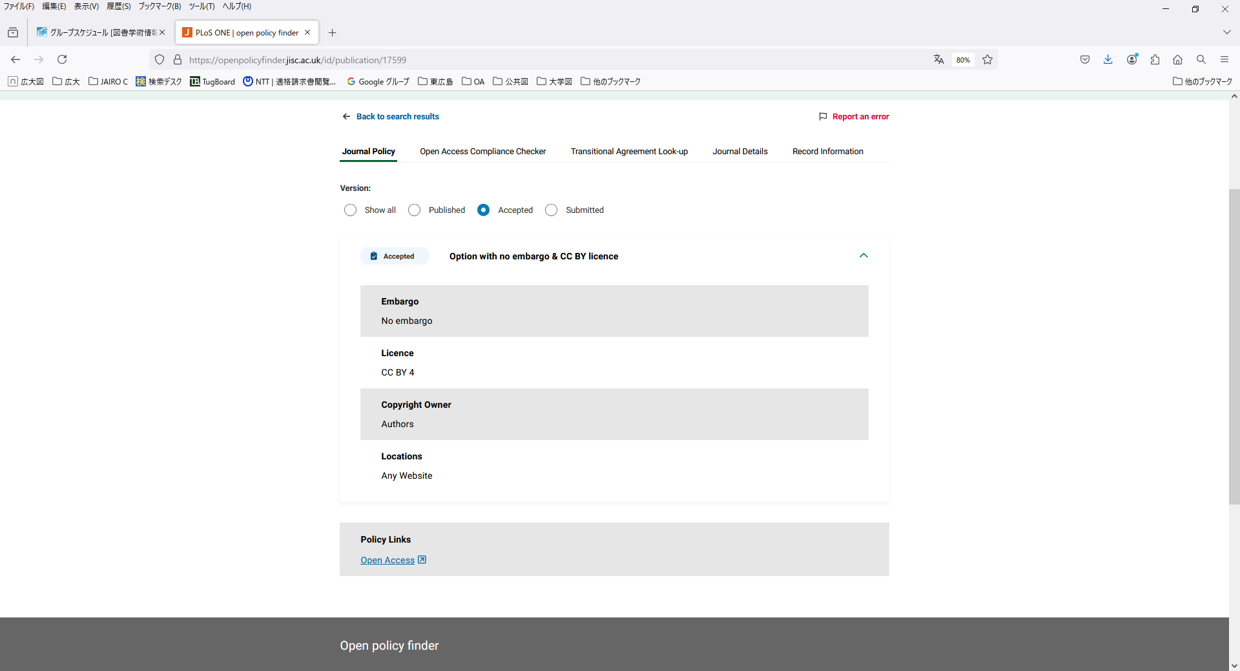

Examples of journals where the publisher's version is Open Access and the author's final draft can be made publicly available in a repository (as of November 2024):

・Frontiers in Neurorobotics, Frontiers in Immunology (Frontiers)

・Cancers, International Journal of Molecular Sciences (MDPI)

**Examples where the author's final draft is labeled as "No accepted version"**

Ex.The Journal of Clinical Investigation (Publisher's version is Open Access)  
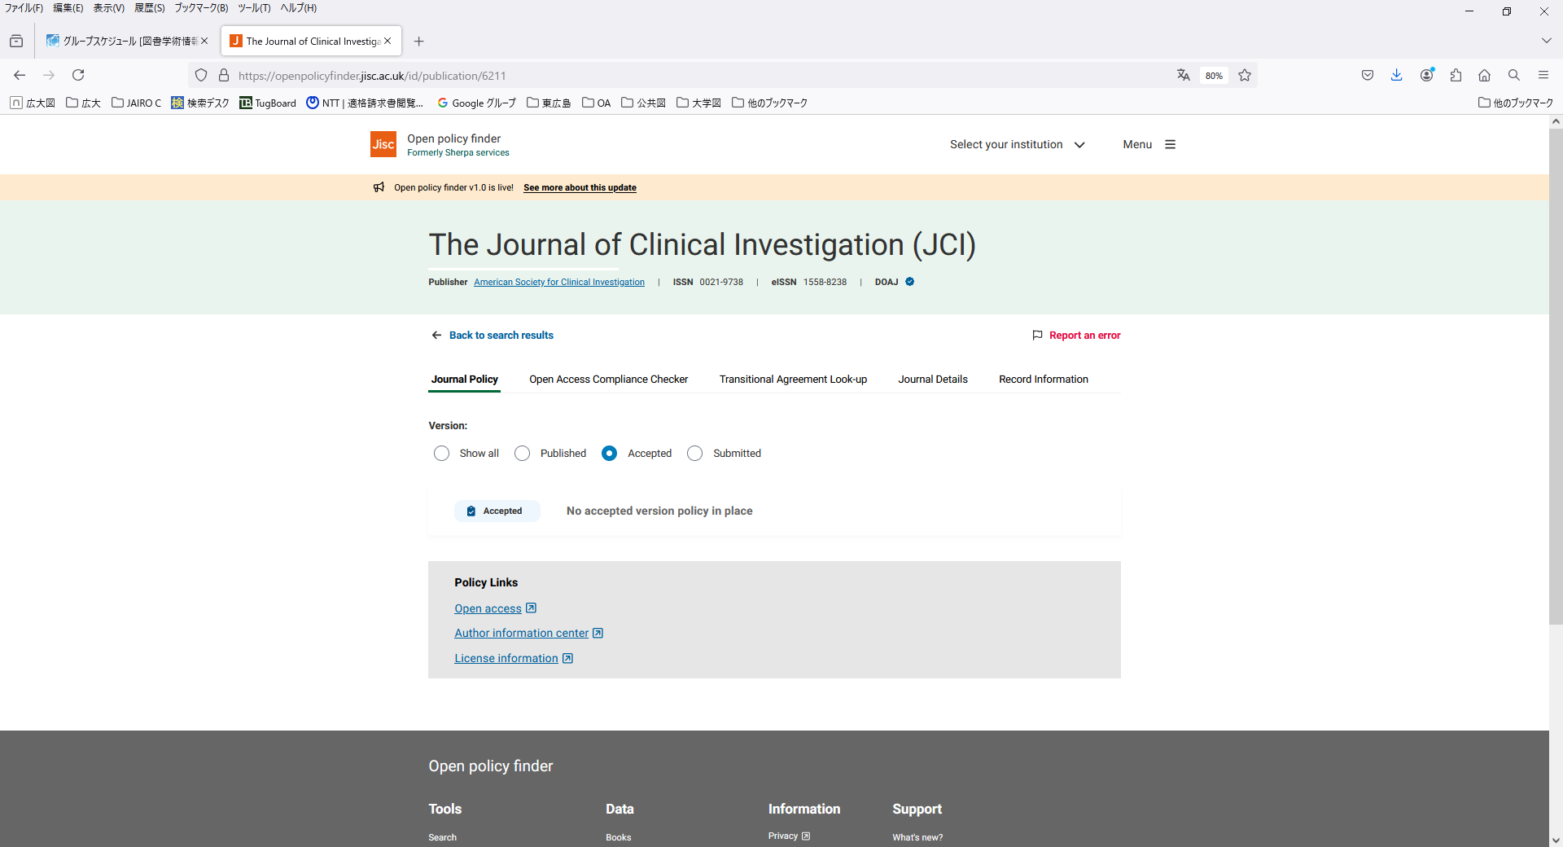  
  
Please review the contractual documents related to the publication of your paper (e.g., copyright transfer forms/agreements or publishing contracts). If the relevant documents do not include this information, directly inquire with the publisher regarding whether repository sharing is permissible.

**Reference: Version of the Article**

It is possible to deposit articles in the Hiroshima University Repository that meet the following conditions.

1. Publisher’s Version

・Open access articles, articles published in Elsevier journals, articles published in Hiroshima Journal of Medical Sciences・広島大学医学雑誌.

1. Author’s Final Version

Only articles that have been allowed to be publicized in the repository by the publisher can be publicized in the repository.

In many cases, it is not the publisher's version itself that is allowed to be registered in the institutional repository, but the author’s final manuscript (the version that reflects the peer review but has not had the final layout adjusted by the publisher, etc.) just before it is accepted by the publisher. It is not permitted to add value (copyediting, formatting, technical improvements, and in some cases page layout) to the author's final manuscript equivalent to that of the publisher's version.

A paper can be viewed as several "versions" at each stage from initial submission to publication, depending on the status of peer review and publisher typesetting.

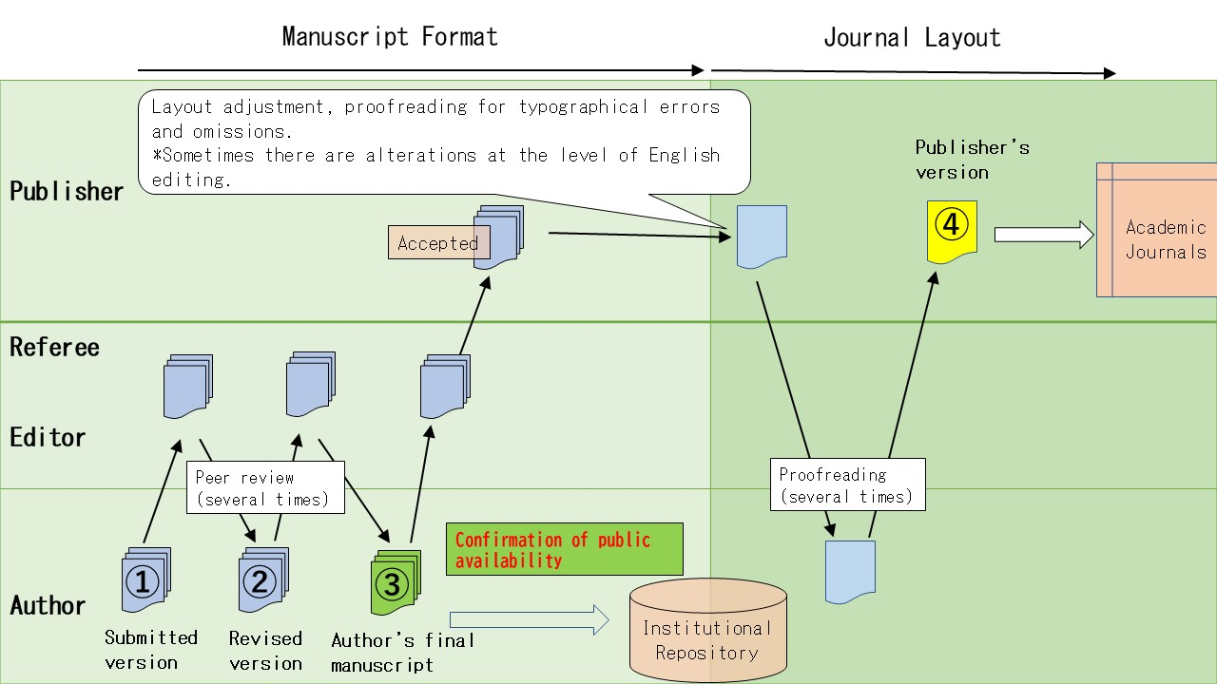

**① Submitted Version** (Manuscript that has been submitted to a publisher before being peer reviewed)   
submitted version, pre-print

**② Revised Version** (Manuscript that has been revised after peer-review)  
revised version

**③ Author’s Final Manuscript Version** (Manuscript just before it is accepted by the publisher after peer review)   
final author's manuscript, accepted author manuscript, peer-reviewed version, post-print

**④ Publisher’s Version** (Manuscripts that were accepted, typeset by a publisher and published in a journal)　  
publisher's version, final publisher's version, VoR (Version of Record)